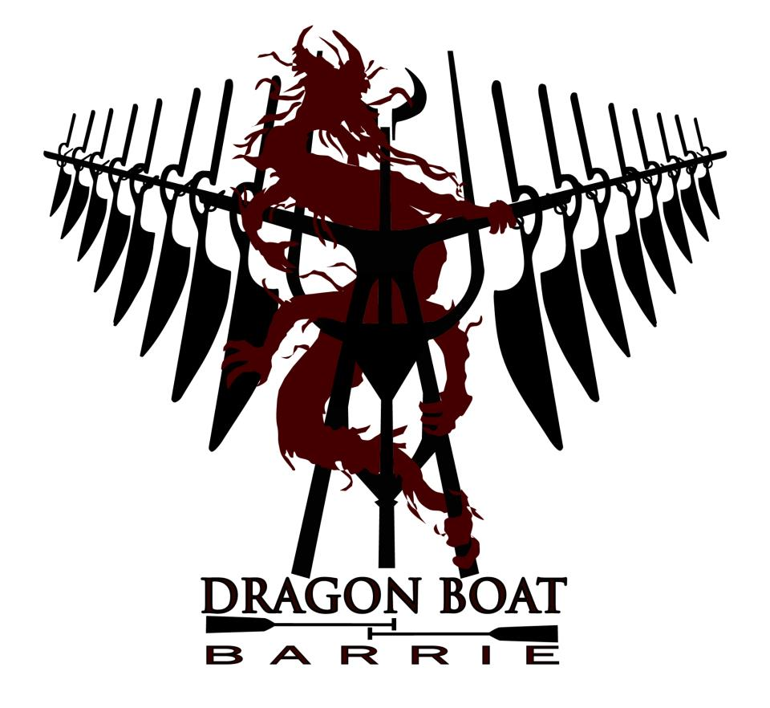

WATER SAFETY PROCEDURES
FOR DRAGON BOAT BARRIE TEAMS
2015

WATER SAFETY PROCEDURES
FOR DRAGON BOAT BARRIE TEAMS
- PREAMBLE
  - Safety of all club members is the number one priority in helping all members paddle/steer/drum in a rewarding and secure environment.
  - This manual is to be used primarily by the Drummers, Steerspersons, Coaches, and Team Captains and Paddlers as a guide.
  - The Drummer and Steersperson are in control of the dragon boat and are in the best position to make decisions involving safety (i.e. determining whether the boat and crew remain on the water, or return to dock, or head for calmer water, etc). This responsibility is also shared with the Coach and Team Captains.
- DEFINITIONS AND TERMS
  - Bow – front of the dragon boat
  - Buoy – a floating marker that is anchored to the bottom of the lake; mooring buoys are attached to a boat when it is not being used for a practice or race, or used to mark lanes/areas
  - Gunnel – upper side edge of the dragon boat.
  - Mooring Rope – rope that is located at the bow and stern of the boat to tie the boat to the docks, or to a mooring buoy in the lake
  - PFD – Personal Floatation Device; must be coast guard approved life jackets
  - Stern – back of the dragon boat
  - Emergency Services – Any first responders to an emergency situation (i.e.: Barrie Police, South Simcoe Police & OPP)
- MEMBER PERSONAL SAFETY
  - PFDs are provided to all members by the City of Barrie and must be worn in the proper manner at all times while in the dragon boat and on the dock.
  - Each member should be able to swim and be comfortable in water. If not, that member must alert the Team Captain and Coaching Group.
  - Each crew member is solely responsible for his or her own safety at any time while engaging in activities related to practicing and racing in the dragon boat.
  - Any injuries occurring as a result of participating in the practices or races must be reported immediately to the Team Captain or Coaching Group.
  - Water Safety Procedures For Dragon Boat Barrie Teams must be observed at all times during practices and where applicable, during races.
- PERSONAL FLOATATION DEVICE (PFD): USE AND CARE
  - Personal Floatation Devices (PFDs) must be worn at ALL times while on the docks and while in the dragon boat. There are absolutely NO exceptions to this rule.
  - All members are supplied with a PFD from the City of Barrie to use during practice and race events. Personal PFDs are authorized for use, and if used shall be used at your own risk.
  - To ensure safety for yourself and your team, please select the proper size of PFD based on your body size and type. If unsure, please check with your Team Captain or Coach.
  - DO NOT sit or rest on PFDs. The added compression to the PFDs will decrease the PFDs buoyancy.
- CHAIN OF COMMAND
  - Always obey the CHAIN of COMMAND.
    - 1st in Command – Steersperson/Drummer
    - 2nd in Command – Drummer/Steersperson
    - 3rd in Command – Coach
    - 4th in Command – Team Captain
    - 5th in Command – Team Co-Captain
- CHECKING BOAT BALANCE
  - DRUMMER AND STEERSPERSON WILL COORDINATE AND EXECUTE THE FOLLOWING:
    - After members have boarded the boat, the mooring ropes are untied.
    - Request paddlers to push off from dock using their hands. DO NOT use the blade end of the paddle. Let the dragon boat come to rest.
    - Ensure everyone is next to the gunnel and sitting straight up.
    - Check the balance.
    - Have paddlers move positions as required to balance boat. (refer to Section 7.0).
    - Once the dragon boat is balanced as best as possible, commence with the practice.
- SEAT CHANGES WITHIN A DRAGON BOAT
  - DRUMMER AND STEERSPERSON WILL COORDINATE AND EXECUTE THE FOLLOWING:
    - The Captain and the Coach will try to balance the boat prior to boarding. Drummer and Steersperson will make required changes to seating arrangement, if there is an imbalance, after the boat has been loaded.
    - If paddlers need to move to another seat, “check” (stop) the dragon boat.
    - All paddlers must “feather the water” while the dragon boat is at a complete stop. This keeps the dragon boat stable from side to side (left to right). Continue to “feather the water” until the Drummer or Steersperson instructs the paddlers to stop.
    - One paddler at a time, as instructed by the Drummer or Steersperson, shall be moved within the dragon boat.
    - Once all the seat changes are made, Drummer or Steersperson instructs the paddlers to release “let it ride” and practice continues.
- DRAGON BOAT RESCUE PROCEDURE
  - SWAMPED OR CAPSIZED DRAGON BOAT DURING A RACE OR PRACTICE.
    - Once a dragon boat begins to capsize, it is very difficult to stop it. If you are on the higher side of the boat when it begins to go over, try to jump clear of your seat partner to avoid injury to him/her.
    - If you come up under the boat, it will be dark, but there will be an air pocket available for you to catch your breath and get your bearings.
    - Feel your way to the side of the boat and then surface on the outside. All individuals MUST stay with the dragon boat. Hold the dragon boat gunnels to help remain with the dragon boat.
    - The “Buddy System” (see 8.2) will be utilized – all paddlers must ensure their seat partner is present. The coaching pod will be “buddied” up with each other. The Drummer, Coach, Steersperson or Captain will initiate a head count (i.e. roll call of the paddlers in their seated rows). The total number of paddlers in the capsized dragon boat must equate to the number of paddlers at the start of each practice. If a member is missing, refer to section 8.3.
    - Next in Command (see 6.0 for chain of command) to determine if any person(s) is injured or requires immediate assistance.
    - Once all paddlers are accounted for, stay calm and stay with the boat. Next in Command to use whistle to attract attention from individuals on shore or in other vessels. A dragon boat in distress is easily recognizable. A call will be made to Emergency Services as soon as possible.
    - Once the Emergency Services arrive, follow the directions given. Emergency Services will be in control of the situation now and the only contact between the team and the patrol is the Next in Command.
    - Next in Command will notify the rescue services if any person(s) requires immediate assistance. Help those in need to the patrol boat first.
    - Emergency Services will remove the paddlers from the water as soon as possible. They may shuttle groups to the nearest shore or to the dock depending on the distance.
  - THE “BUDDY SYSTEM”
    - Know the person paddling in the seat next to you. In the event of an incident, you are responsible for ensuring that your partner is present and assess whether they are injured.
    - Each person is also assigned a row number from 1 to 12 before loading onto the dragon boat. The Next in Command can initiate a roll call to account for everyone in the dragon boat.
    - The coaching pod (drummer, coach, steersperson) will be “buddied” up with each other - responsible for ensuring the pod is accounted for, and assess for injuries.
  - MISSING INDIVIDUAL “FIND AND RESCUE PROCEDURE”
    - Have paddlers look and feel around for the missing paddler(s) in their immediate vicinity without leaving the dragon boat.
    - Each paddler to feel under the boat, within their immediate proximity, to see if the missing paddler is under the boat.
    - If necessary, one individual ONLY, should check under the boat to ensure the missing person is not trapped underneath. This one individual will be assigned by the Next in Command.
    - Notify Emergency Services as soon as they arrive, of missing person(s), if person(s) is/are not found by then.
    - Once Emergency Services arrives, Emergency Services will be in control of the situation now and the only contact between the team and Emergency Services is the Next in Command.
  - SWIMMING TO SHORE IN THE EVENT OF A CAPSIZE OR SWAMPED DRAGON BOAT
    - This option can ONLY be exercised if the dragon boat is located approximately 50 meters away from shore.
    - Once the entire team is accounted for, a TEAM decision can be made on whether to stay with the dragon boat and wait for Emergency Services, or swim to shore.
    - If ANY individual on the team is not comfortable swimming to shore, the entire TEAM shall remain together with the dragon boat.
    - If the decision is to swim to shore, a head count is required on shore to ensure the entire team is accounted for.
- WEATHER, WAVE AND WIND PATTERNS
  - If the coaching pod does not have the experience/skill necessary to ensure a safe practice, the team does not go out onto the lake. The Coach, Captain, Drummer and Steersperson can decide not to proceed with practice based on weather and the following considerations: Steersperson’s level of experience and confidence AND Paddlers’ level of experience and confidence
  - WAVE AND WIND PATTERNS
    - Direct side waves are most dangerous for swamping/sinking the boat. As water goes over the side/gunnel, the respective side of the boat begins to sink, letting in even more water.
    - Be aware of heavy crews in waves, as they are already sitting low in the water.
    - Head winds are less likely to sink the boat but will make it difficult getting back to the dock. If you are paddling with a novice crew, it may take a long time. Do not panic and force the crew to get back to dock faster. Remain calm and encourage the crew with a steady paddle.
    - When the boat becomes unstable, some paddlers will panic and stop paddling. This will cause even more instability to the boat. Encourage paddlers to continue paddling to minimize the chance of swamping/capsizing.
    - Steersperson should be familiar with how to compensate for the wind/waves. It is best to orientate the dragon boat with or against the direction of the wave, to avoid the waves hitting the dragon boat on the sides.
    - If a storm is approaching with high winds, it is recommended that you follow the shoreline back to dock.
- MANDATORY DRAGON BOAT EQUIPMENT REQUIRED ON BOARD DURING PRACTICE
  - THE DRAGON BOAT MUST CONTAIN THE FOLLOWING EQUIPMENT AT ALL TIMES DURING A PRACTICE:
    - At least one (1) bailer located underneath the last row.
    - Two (2) whistles, one with the Drummer and one with the Steersperson.
    - Basic First Aid Kit
- REFERENCE MATERIAL
  - City of Barrie Water Safety: http://www.barrie.ca/Living/RecreationFacilities/Pages/WaterSafety.aspx

